MNIST Tanh:

Not normalized (images in 0-255):

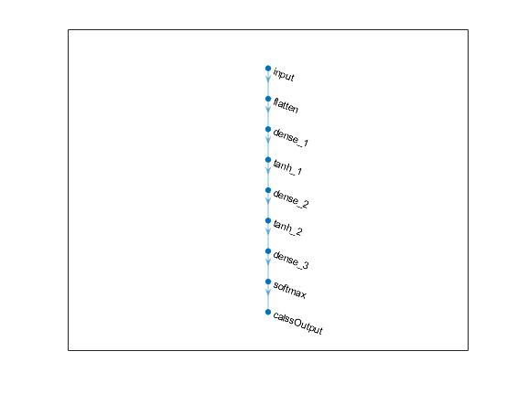

Validation accuracy: 95.96%

Test accuracy = 95.52%

MNIST Tanh:

Normalized (images in 0-1):



Validation accuracy: 97.01%

Test accuracy = 97.24%



